Course Selection: Language Arts, Reading, Mathematics, Social Studies, and Science are automatically assigned to students based on FAST Test Scores, NWEA Scores, and/or other student achievement data.

**If you would like your student to be exempt from Physical Education, please fill out the PE waiver on the reverse side of this form**

 | Year Long Courses |  |  | Semester Courses (1/2 year)
 | Band 1 |  |  | Health
 | Band 2 |  |  | PE (Semester Only – 1 time for the year)
 | Jazz Band (Teacher Approval) |  |  | Teacher Assistant (Ms. Ford & Admin Approval)
 | Orchestra 1 |  |  | Spanish Exploration
 | Orchestra 2 |  |  | Art 1
 | Chorus 1 |  |  | Art 2
 | Chorus 2 |  |  | FL Ecosystem 1 (Fishing 1)
 | Theatre 2 (Teacher Approval) |  |  | FL Ecosystem 2 (Fishing 2)
 | Exploration of Robotics Technology |  |  | Music Exploration
 | PE (Full Year) |  |  | Beginning Theatre
 | Spanish 1(High School Credit & Admin Approval) |  |  | Keyboarding (Computer)
 | AVID |  |  | Computer Applications
You May Choose
2 of the Year Long Courses
OR
1 of the Year Long Courses with 2 of the Semester Courses
OR
4 of the Semester Courses

Number your choices with the MOST IMPORTANT being #1
QR Code: 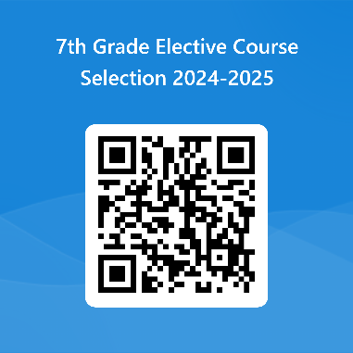 Link: https://forms.office.com/r/gpaBY6yJCD
Turn in to Mrs. Rousch or in Café at Lunch Time

Although every effort will be made to accommodate students’ requests, selecting a course does not guarantee placement.
By signing below you are stating that these are the courses that you have requested.

St. Cloud Middle School
Physical Education Waiver

I, _________________________________ request a PE waiver for my son/daughter,
(Parent Name)

________________________________________ for the 2024-25 school year.
(Student Name & ID #)

I am requesting a PE waiver, because my child participates in the following physical activity(s) outside of school: ___________________________________________________________

__________________________________________________________________________.
(THIS IS A REQUIRED ENTRY TO BE ACCEPTED AS A WAIVER)

________________________________ ___________________________
Print Student Name Student ID #

_________________________________ ____________________________
Print Parent Name Parent Phone Number

_________________________________ ___________________________
Parent Signature

